Greedy Best-First Search – Romania Map

Problem Statement:
Find a path from the source node Arad to the goal node Bucharest using Greedy Best-First Search.

Initial State: Arad
Goal State: Bucharest

AI Technique: Greedy Best-First Search

Heuristic Function:
f(n) = h(n)
where h(n) is the estimated straight-line distance from the current city to Bucharest.

Why selected:
Greedy Best-First Search is suitable because the Romania map provides heuristic information in the form of straight-line distances. It always expands the node that appears closest to the goal. This can reduce unnecessary exploration compared with uninformed search. However, it does not guarantee the shortest path because it ignores the cost already travelled.

Expansion Order:
Arad → Sibiu → Fagaras → Bucharest
Path Found:
Arad → Sibiu → Fagaras → Bucharest

Complexity:
Time: O(b^m)
Space: O(b^m)

Advantages:
Uses heuristic information.
Can reach the goal quickly.
Simple priority-queue implementation.

Limitation:
Does not guarantee an optimal path.

Conclusion:
Greedy Best-First Search successfully reaches Bucharest by selecting the node with the lowest heuristic value

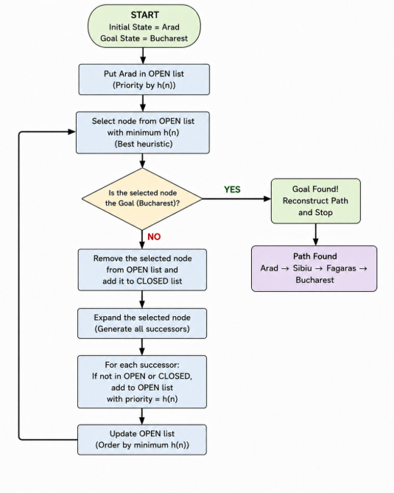

A* Search-Delivery Robot

Problem Statement:
Find the optimal path for a delivery robot from the warehouse to the customer using A* Search.

Initial State: Warehouse
Goal State: Customer

AI Technique: A* Search

Evaluation Function:
f(n) = g(n) + h(n)
where g(n) is the actual cost from the warehouse to the current node and h(n) is the estimated cost from the current node to the customer.

Why selected:
A* Search is suitable because the delivery problem involves a weighted road network where the robot needs to find a minimum-cost path. It combines the actual cost travelled with the estimated remaining cost. Unlike Greedy Best-First Search, A* considers both g(n) and h(n) and can guarantee an optimal path when the heuristic is admissible.

Expansion Order:
Warehouse → B → D → Customer
Path Found:
Warehouse → B → D → Customer
Total Path Cost:
2 + 5 + 2 = 9
Complexity:
Time: O(b^d)
Space: O(b^d)

Advantages:
Uses both actual and heuristic cost.
Can find an optimal path with an admissible heuristic.More efficient than uninformed search when a good heuristic is available.
Limitation:
Can require high memory and computation for large search spaces.

Conclusion:
A* Search successfully finds the minimum-cost route by considering both the cost already travelled and the estimated cost to the goal. The optimal path is Warehouse → B → D → Customer, with a total cost of 9.

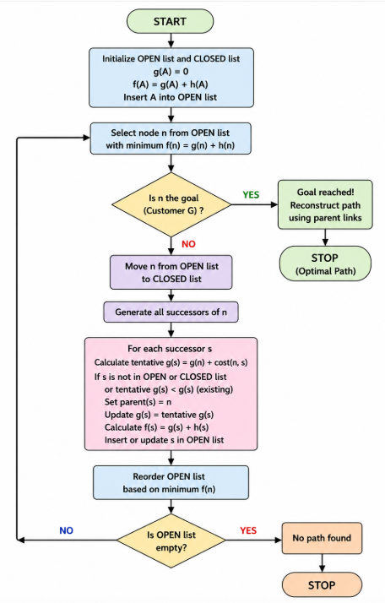
CSP with MRV and Forward Checking – Examination Timetable

Problem Statement:
Prepare a valid university examination timetable by assigning subjects to different time slots using Constraint Satisfaction Problem (CSP).
Initial State: No subjects are assigned to examination slots.
Goal State: All subjects are assigned to valid slots without violating any constraints.
AI Technique: Constraint Satisfaction Problem (CSP) with MRV and Forward Checking
Variables:
Subjects such as AI, DBMS, Operating Systems, Mathematics and Computer Networks.
Domains:
Each subject can be assigned to available examination slots such as S1, S2 and S3.
Constraints:
Subjects having common students cannot be scheduled in the same examination slot.
Why selected:
CSP is suitable because the examination timetable contains variables, possible values and constraints. MRV selects the subject with the fewest remaining valid slots, while Forward Checking removes conflicting slots from the domains of related subjects. This reduces unnecessary backtracking and makes the scheduling process more efficient.
Working:
First, a subject is selected using MRV. After assigning a slot, Forward Checking removes that slot from conflicting subjects. If a domain becomes empty, the algorithm backtracks and tries another slot.
Complexity:
Time: O(dⁿ)
Space: O(n)
Advantages:
MRV selects the most constrained subject first.
Forward Checking detects conflicts early.
Limitation:
The worst-case search can still be exponential when the number of subjects and constraints becomes large.
Conclusion:
CSP with MRV and Forward Checking successfully produces a valid examination timetable while satisfying the given constraints.

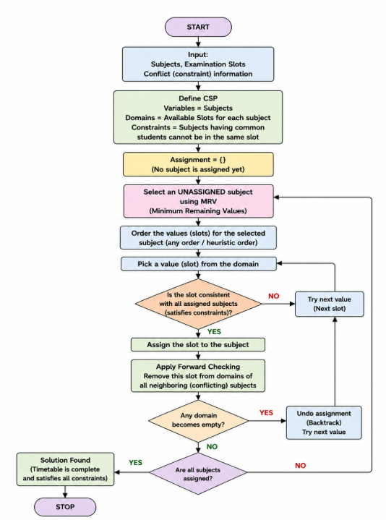

Minimax with Alpha-Beta Pruning – Game Tree
Problem Statement:
Determine the best move for the MAX player in a two-player game using the Minimax algorithm and improve the search using Alpha-Beta Pruning.
Initial State: Root node of the game tree.
Goal State: Determine the best move for MAX.
AI Technique: Minimax with Alpha-Beta Pruning
Evaluation:
MAX selects the maximum value, while MIN selects the minimum value from the available game-tree branches.
Why selected:
Minimax is suitable for two-player games where both players play optimally. It considers the possible moves of both MAX and MIN before selecting the best move. Alpha-Beta Pruning improves Minimax by eliminating branches that cannot affect the final decision. This reduces unnecessary node evaluation while producing the same optimal result.
Game Tree Evaluation:
A = MIN(5, 9) = 5
B = MIN(2, 8) = 2
Therefore: MAX(5, 2) = 5,Best Move:A
Pruned Nodes:
The F subtree and its leaf nodes 8 and 4 are pruned because α ≥ β.
Nodes Evaluated:
Minimax: 15 nodes
Alpha-Beta: 12 nodes
Nodes saved: 3
Complexity:
Minimax Time: O(b^d)
Alpha-Beta Time: O(b^d) worst case
Best case with good ordering: O(b^(d/2))
Advantages:
Finds the optimal move against an optimal opponent.
Alpha-Beta reduces unnecessary node evaluation.
Produces the same result as Minimax.
Limitation:
Large game trees can require high computation, and Alpha-Beta efficiency depends on the ordering of moves.
Conclusion:
Minimax determines that A is the best move for MAX with a utility value of 5. Alpha-Beta Pruning reaches the same result while avoiding unnecessary evaluation of the F branch, making the search more efficient.

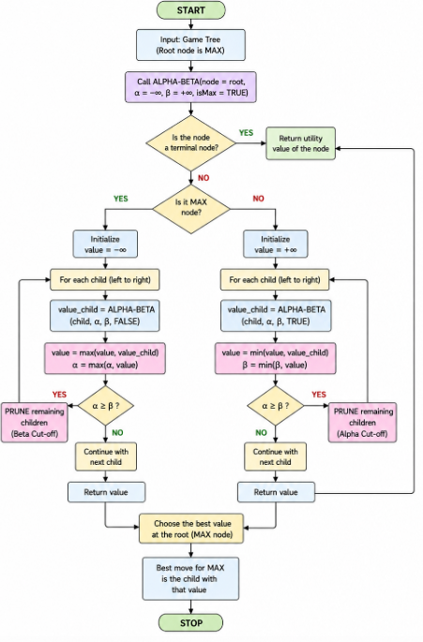

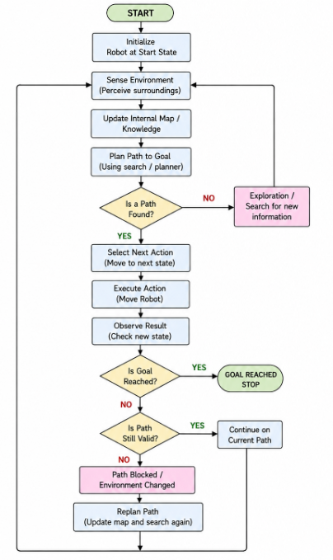
Online Search Agent – Dynamic Warehouse Robot
Problem Statement:
Design an intelligent search strategy for a warehouse robot that can reach its destination while adapting to unexpected obstacles and changes in the environment.
Initial State: Robot is at the starting warehouse location.
Goal State: Robot reaches the required destination safely.
AI Technique: Online Search Agent
Working Principle:
The robot continuously senses the environment, updates its knowledge, plans a path, takes an action, and observes the result. If an unexpected obstacle appears, it changes its route and continues searching.
Why selected:
Online Search is suitable because the warehouse environment is dynamic and may not be completely known in advance. Unlike a fixed informed-search plan, the robot can react to new obstacles during execution. It can update its internal map and replan whenever the current path becomes blocked.
Execution:
Sense Environment → Update Map → Plan Path → Take Action → Observe → Replan
If an obstacle appears:
Detect Obstacle → Update Map → Find New Path → Continue Movement
Adaptation:
The robot does not blindly follow the original path. It observes changes in the environment and selects an alternative safe route when necessary.
Complexity:
Time: O(k × b^d)
Space: O(b^d)
where k is the number of replanning operations.
Advantages:
Adapts to unexpected obstacles.
Works in partially known environments.
Limitation:
Frequent replanning can increase computational cost and depends on reliable sensor information.
Conclusion:
The Online Search Agent is effective for dynamic warehouse navigation because it continuously observes the environment and adapts its path. It provides greater flexibility than a fixed search plan when unexpected obstacles occur.

